***Bug title:***

**[Chrome/FIrefox][Our Store]: Google map widget could not be loaded properly**

***Bug Description:***  
This issue occurs in Our Store page

User launch Chrome/firefox browser and opens *automationpractice.com*, then user goes to Our store page by clicking the link on the footer. After Our Store page is loaded, **user will notice that Google map widget could not be loaded properly**

**Expected result:** Google map should be loaded and displayed properly in order for user to find the store more easily

**Actual result** : Google map could not be loaded and displayed properly and also An error popup is displayed that prevents user to use the map

Please see attachment for details.

Steps:  
1. Launch Browser

2. Go to automationpractice.com

3. Click “Our Store” Link on the footer of the website  
4. Observe “Our Store” page

5. Notice that Google map could not be loaded properly

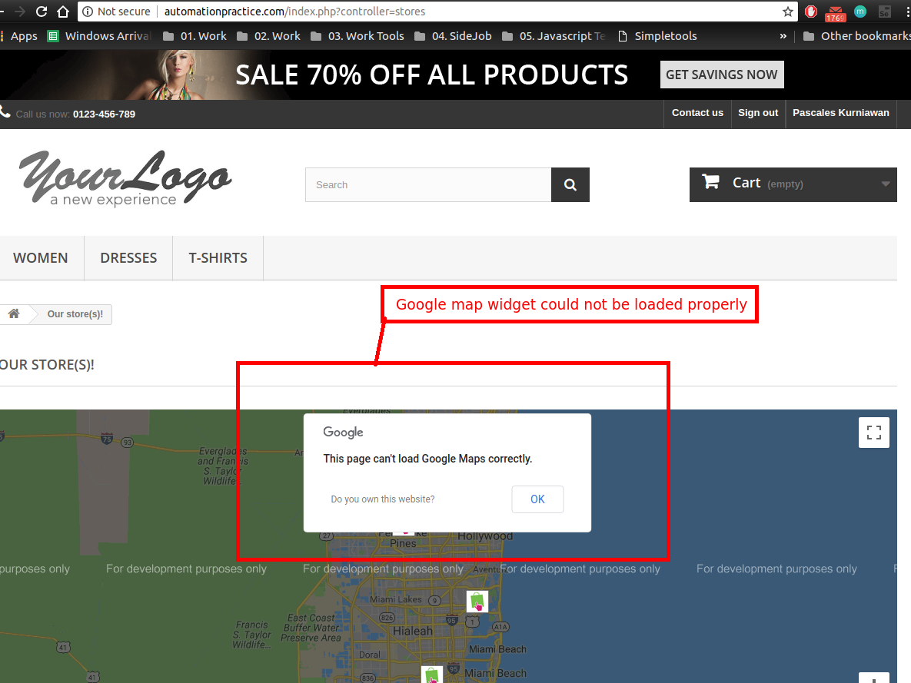

Attachment:

***Bug title:***

**[Chrome/Firefox][Facebook Block]:** **Facebook block/widget could not be loaded and displayed properly**

***Bug Description:***  
This issue occurs in Home page

User launch Chrome/firefox browser and opens *automationpractice.com*, After the home page is successfully loaded, user scrolls down to the block section, user will notice that **Facebook block/widget could not be loaded and displayed properly**

**Expected result:** Facebook block / widget should be loaded and displayed properly, in order for user to follow the company facebook page and increases user engagement.

**Actual result** : Facebook block / widget could not be loaded and displayed properly it only displays blank content

Please see attachment for details.

Steps:  
1. Launch Browser

2. Go to automationpractice.com

3. Scroll down until facebook widget / block  
4. Observe “Our Store” page

5. Notice that Facebook block/widget could not be loaded and displayed properly

Attachment:

